IRKUTSK SCIENCE CENTER
DEPARTMENT OF FOREIGN LANGUAGES

MULTIDISCIPLINARY YOUTH ACADEMIC RESEARCH CONFERENCE

«Science Present and Future: Research Landscape in the 21st century»

Program

May 17-18 2017
Section 1. Maths and IT Technologies
Wednesday, 17 May 2017
Venue конференц-зал ИДСТУ СО РАН, № 407
Time: 10.00-13.00
Moderators: Raissa T. Kalinina, Assistant Professor,ISC SB RAS Ivan V. Russkikh, ISTP SB RAS
 | Author | Institute | Abstract title
 | Aleksey D. Kononov | ISDCT  SB RAS | Robust stability of differential-algebraic equations
 | Elena S. Isaeva | ISTP  SB RAS | The space-time distribution of proton flares on the Sun.
 | Roman O. Kostromin  Yuri A. Dyadkin | ISDCT  SB RAS | Improving the reliability and performance of a data storage system with RAID technology
 | Irina A. Gribanova | ISDCT  SB RAS | SAT-based Сryptanalysis
 | Ksenia V. Bedenko | ISDCT SB RAS | Underwater environment generation as a part of simulation modeling system of underwater vehicles
 | Ivan V. Russkikh  Dmitry Y. Kolobov | ISTP  SB RAS | Developing optical and electronic devices for high resolution observations
 | Maksim .F. Artamonov, RomanV. Vasilyev | ISTP  SB RAS | Modeling interferogram images for the output data simulation of Fabry-Perot interferometer
 | Dmitry A. Zatolokin | ISTP  SB RAS | Comparison of ionospheric models of the total electron content for the Glonass system
 | Sergey V. Latyshev | ISTP  SB RAS | Correlation of North-South asymmetry of spot-formation with amplitude of 11- year cycles of solar activity
 | Roman .K. Fedorov,  Alexander S. Shumilov | ISDCT  SB RAS | Geoportal technologies to support interdisciplinary research

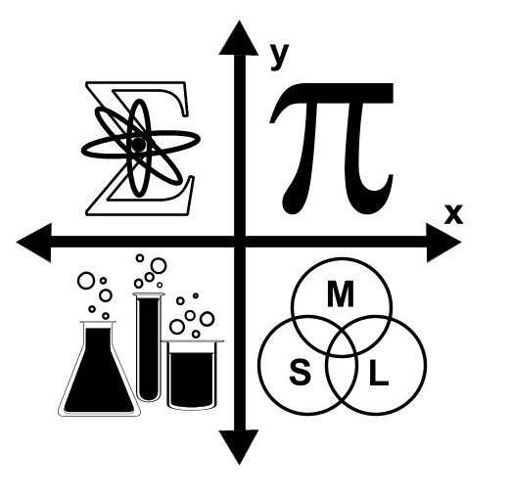

Section 2. Power Engineering and Technology
Wednesday, 17 May, 2017
Venue конференц-зал ИДСТУ СО РАН, № 407
Time: 14.00-17.00
Moderators: Nadezhda N. Efimova, PhD (Philology), Associate, ISC SB RAS
Sergey Perzhabinsky, PhD (Physics and Mathematics) ESI SB RAS
 | Author | Institute | Abstract title
 | Vitaly E. Alexeyuk | ESI SB RAS | Mathematical models of heat power plants: improvement of identification methods
 | Veronika B. Shelekhova | ESI SB RAS | Challenges and prospects of active energy consumption systems
 | Ivan L. Trofimov | ESI SB RAS | Data search and processing for pre-project analysis and forecasting of energy cooperation in Northeast Asia. on the example of China
 | Anastasiya A. Mukanina | ESI SB RAS | The simulation model of the Multi-Energy System
 | Elena A. Andreyeva | ESI SB RAS | Optimization of autonomous energy supply systems using renewable energy sources based on consumer load uncertainty
 | Alexander Voronin | ESI SB RAS | Comparative analysis of the operating modes of the traditional and active-adaptive distribution electric Networks
 | Matvey A. Khaptageyev | ESI SB RAS | Cybersecurity of Intelligent Power Systems

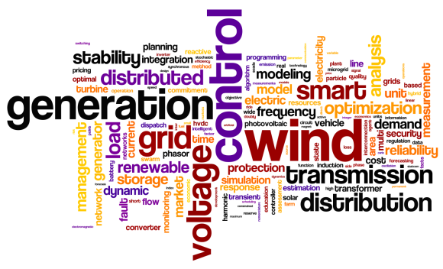

Section 3. Life-sciences on the Cutting Edge of Science
Wednesday, 17 May, 2017
Venue конференц-зал ИДСТУ СО РАН №401
Time: 10.00-13.00
Moderators: Natalia B. Vinokurova, Assistant Professor, ISC SB RAS
Alexandr A. Shishparenok, SIPPB SB RAS
 | Author | Institute | Abstract title
 | Yuriy M. Konstantinov | SIPPB SB RAS | Natural competence of mitochondria for DNA Uptake: evolutionary significance and areas of application
 | Tatyana A. Bolotova | SIPPB SB RAS | Exploring strategies for genetic manipulaton of plant mitochondrial genome
 | Alexandr A. Shishparenok | SIPPB SB RAS | Content of ascorbic acid in apple fruits of Siberian crabapple, domestic apple and their hybrids grown in Siberian conditions.
 | Vadim I. Bel’kov | SIPPB SB RAS | Role of Tetrapyrrole synthesis-mediated signals in GDH1 and GDH2 genes expression in Arabidopsis Thaliana
 | Galina V. Podlesnaya | LIN SB RAS | The study of microorganisms of the nitrogen cycle in lake Baikal
 | Tatyana A. Babenko | LIN SB RAS | Evaluation of DEHP in Baikal waters
 | Yulia P. Sapozhnikova | LIN SB RAS | The effects of intense acoustic stimulation on the auditory behavior and epithelium ultrastructure of Baikal fish
 | Yuri I. Litvintsev | IIC SB RAS | Synthesis of new functional organophosphorus compounds based on elemental phosphorus
 | Anastasia A. Ivanova | IIC SB RAS | Silver and gold Nanocomposites based by Copolymers of 1-Vinyl-1,2,4-Triazole with N-Vinylpyrrolidone.
 | Evgeniy A. Sekretarev | IIC SB RAS | Copolymerization of 1-vinyl-1,2,4-triazole with Allylamine
 | Anton S. Ganin | IIC SB RAS | Oxidative addition of unsaturated Triflamide substances and their interaction with each other

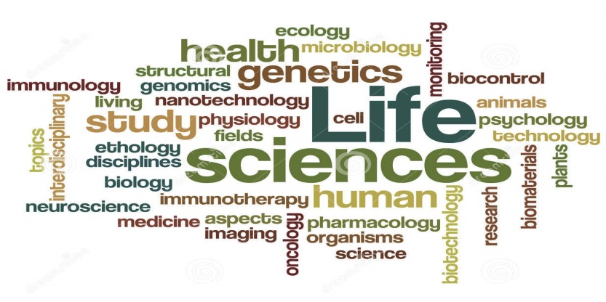

Section 4. Geosciences, Solar Sciences and Hydrosciences: New Frontiers
Wednesday, 17 May, 2017
Venue конференц-зал ИГХ СО РАН
Time: 09.00-12.00
Moderators: Ludmila A. Shulgina, Assistant Professor, ISC SB RAS
Anna A. Zak, IGC SB RAS
 | Author | Institute | Abstract title
 | Aleksey N. Kosterev | IGC SB RAS | 3-D multielemental geochemical models in solving the problems of geological studies of the Earth interior
 | Aleksey O. Mikhalyov | IGC SB RAS | Architecture of information systems and methods of data generalization to create local geoportals for geochemical purposes
 | Tatiana G. Bukhaeva  Maria N. Zvereva | IG SB RAS | Gender features of the crimes related to violence in family
 | Dmitry O. Sofich: | IGC SB RAS | Optical spectroscopy of double molibdates with rare earths
 | Alexander A. Ivanov | IGC SB RAS | Modern methods of hydrodynamic processes calculation
 | Alexander I. Bogdanov | IGC SB RAS | Theoretical study of Structural inhomogeniety in lead Zirconate Titanate Piezoelectric Material
 | Victoria V. Boroldoeva | IGC SB RAS | Geochemistry of alkaline picrobasalts of the Hentei range.
 | Denis А. Belkov | IGC SB RAS | Geodynamic typification of granitoids according to geochemical data
 | Anton S. Tarasyuk | IGC SB RAS | Rare Earth elements in the Syenites of Saibar Massif of the Minusinsk trough (Altai-Sayan Rift System)
 | Yulia S. Andreeva | IGC SB RAS | Petrogenesis of late mesozoic volcanic rocks of trachybasalt series of Eastern Transbaikalia

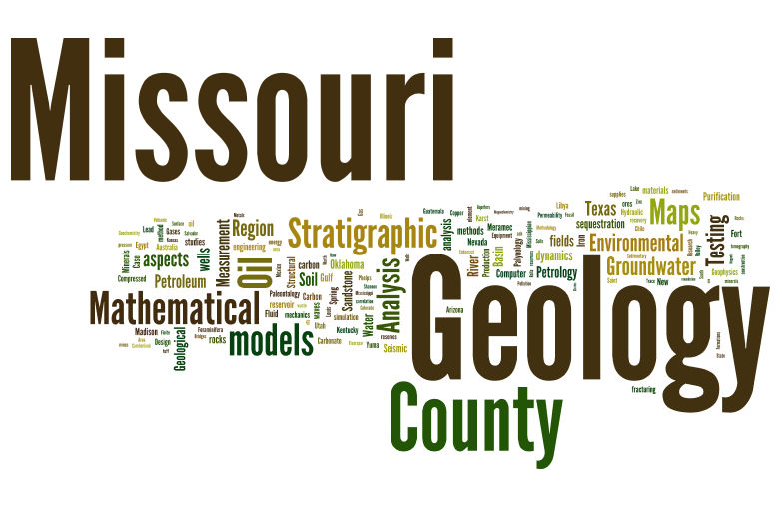
Section 5. Language Research and Teaching: Legacy and Future
Thursday, 18 May, 2017
Venue конференц-зал ИДСТУ СО РАН, № 407
Time: 10.00-13.00
Moderator: Galina A. Ageeva, PhD (Philology), Associate Professor, ISC SB RAS
 | Author | Institute | Abstract title
 | Anna Y. Suslova | ISU | How to get research articles published in professional journals: “Rules of the game”
 | Elizaveta V. Podkamennaya | ISU | Teaching public relations students how to write PR-texts in English
 | Natalya V. Yelashkina | INRTU | The importance of study competence
 | Svetlana V. Latysheva | INRTU | Indirect speech utterance as the categorization of communicative situation
 | Raissa T. Kalinina | ISC SB RAS | Noun chain determiners
 | Ludmila A. Shulgina | ISC SB RAS | Gentle Grafter vs Romance Scammer
 | Natalia B. Vinokurova | ISC SB RAS | Limericks as means of learning English
 | Galina A. Ageeva | ISC SB RAS | English language refreshing: positive transfer and interference  (own experience)
 | Tatiana V. Bounaeva | IGC SB RAS | Effects of storytelling using web-based multimedia system on English as foreign language speaking
 | Nadezhda N. Efimova | ISC SB RAS | Linguo-didactic strategies of polyglots

